**MODEL EVALUATION**

**Evaluate the model's performance on the testing**

**dataset using appropriate metrics (e.g., accuracy,**

**precision, recall).**

**Visualize the results with confusion matrices classification reports.**

**Understanding Logistic Regression with Standardization**

In this document , we will explore and explain a Python code snippet that involves logistic regression, standardization, and evaluation metrics. The goal is to provide a comprehensive understanding for individuals who may be new to these concepts.

**Libraries Used:**

```python

from sklearn.linear_model import LogisticRegression

from sklearn.model_selection import train_test_split

from sklearn.preprocessing import StandardScaler

from sklearn.metrics import accuracy_score, precision_score, recall_score, confusion_matrix, classification_report

```

**- Logistic Regression** (`LogisticRegression`):

- A machine learning algorithm used for binary classification.

- Models the probability of an instance belonging to a particular class.

- **Train-Test Split** (`train_test_split`):

- A method to split a dataset into training and testing sets.

- Allows for training a model on one subset and evaluating its performance on another.

- **Standard Scaler** (`StandardScaler`):

- A preprocessing step to standardize features by scaling them to have a mean of 0 and a standard deviation of 1.

- Important for models sensitive to feature scales, like logistic regression.

- **Metrics** (`accuracy_score`, `precision_score`, `recall_score`, `confusion_matrix`, `classification_report`):**

- Evaluation metrics used to assess the performance of a classification model.

**Code Explanation:**

```python

# Assuming X_train, X_test, y_train, y_test are your feature and target sets

# Splitting the data into training and testing sets

X_train, X_test, y_train, y_test = train_test_split(features, target, test_size=0.2, random_state=42)

```

- **Train-Test Split:**

- Divides the dataset into training and testing subsets.

- `features` represent the input features, and `target` is the corresponding output or labels.

- `test_size=0.2` allocates 20% of the data for testing, and `random_state=42` ensures reproducibility.

```python

# Standardizing the data

scaler = StandardScaler()

X_train_scaled = scaler.fit_transform(X_train)

X_test_scaled = scaler.transform(X_test)

```

- **Data Standardization:**

- `StandardScaler` is used to standardize features.

- `fit_transform` calculates mean and standard deviation from the training data, scaling it accordingly.

- `transform` applies the learned mean and standard deviation to the testing data, ensuring consistent scaling.

```python

# Instantiating and training the logistic regression model

model = LogisticRegression()

model.fit(X_train_scaled, y_train)

```

- **Logistic Regression Model Training**:

- Creates a logistic regression model (`LogisticRegression`).

- `fit` trains the model using the scaled training data (`X_train_scaled`, `y_train`).

```python

# Making predictions on the scaled testing data

y_pred = model.predict(X_test_scaled)

```

**- Making Predictions:**

- Uses the trained logistic regression model to make predictions on the scaled testing data (`X_test_scaled`).

- Predictions are stored in `y_pred`.

```python

**#Evaluating the model**

**#Metrics: accuracy, precision, recall, confusion matrix, classification report**

accuracy = accuracy_score(y_test, y_pred)

precision = precision_score(y_test, y_pred)

recall = recall_score(y_test, y_pred)

conf_matrix = confusion_matrix(y_test, y_pred)

class_report = classification_report(y_test, y_pred)

```

**- Model Evaluation Metrics**:

- Calculates various metrics to assess the performance of the model on the testing data.

- Metrics include accuracy, precision, recall, confusion matrix, and a comprehensive classification report.

**Key Concepts:**

- **Central Tendency and Spread:**

- Mean: The average value of a dataset.

- Standard Deviation: Measures the spread or dispersion of values in a dataset.

- Standardization: Scaling features to have a mean of 0 and a standard deviation of 1.

- **Logistic Regression:**

- A model for binary classification, predicting the probability of an instance belonging to a particular class.

- Trained using optimization algorithms and evaluated using various metrics.

Certainly! Let's provide concise definitions for precision, accuracy, recall, F1 score, and support, and briefly touch on confusion matrices.

1**. Precision:**

Definition:

- Precision measures the accuracy of positive predictions. It is the ratio of true positives to the total positive predictions made by the model.

Formula:

\[ \text{Precision} = \frac{\text{True Positives}}{\text{True Positives + False Positives}} \]

**2. Accuracy:**

Definition:

- Accuracy is the overall correctness of predictions. It is the ratio of correct predictions to the total number of instances.

Formula:

\[ \text{Accuracy} = \frac{\text{Correct Predictions}}{\text{Total Predictions}} \]

3. **Recall (Sensitivity or True Positive Rate):**

Definition:

- Recall measures the ability of a model to capture all relevant instances. It is the ratio of true positives to the total actual positives.

Formula:

\[ \text{Recall} = \frac{\text{True Positives}}{\text{True Positives + False Negatives}} \]

**4. F1 Score:**

Definition:

- F1 score is the harmonic mean of precision and recall, providing a balance between the two metrics.

Formula:

\[ \text{F1 Score} = 2 \times \left( \frac{\text{Precision} \times \text{Recall}}{\text{Precision + Recall}} \right) \]

**5. Support:**

Definition:

- Support is the number of actual occurrences of a class in the dataset. It provides context for precision, recall, and F1 score.

**Confusion Matrix:**

- **A confusion matrix** is a table that summarizes the performance of a classification algorithm. It provides counts of true positives, true negatives, false positives, and false negatives.

- Elements of a confusion matrix:

- True Positive (TP): Instances correctly predicted as positive.

- True Negative (TN): Instances correctly predicted as negative.

- False Positive (FP): Instances incorrectly predicted as positive.

- False Negative (FN): Instances incorrectly predicted as negative.

Understanding these metrics and the confusion matrix collectively aids in assessing the effectiveness of a classification model in various scenarios.

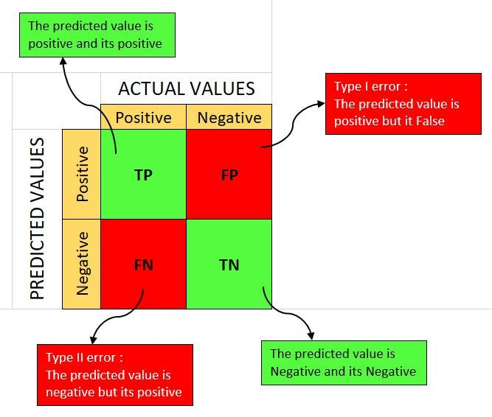 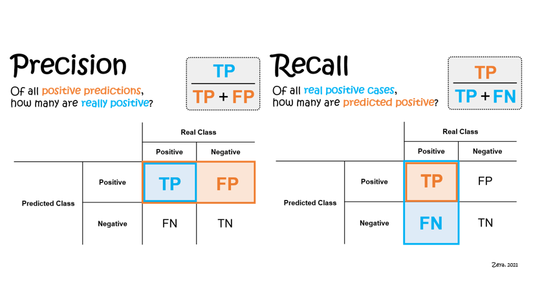

**Conclusion:**

This code snippet demonstrates a standard process for training a logistic regression model, standardizing data, making predictions, and evaluating model performance. Understanding concepts like standardization and evaluation metrics is crucial for effective machine learning model development.